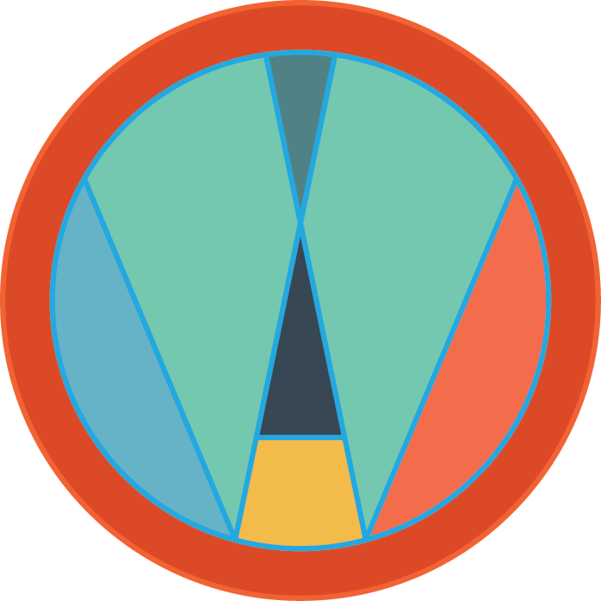

Winthrop Arts’ 1st Annual Totem-lly Bewitching Pumpkin Party
October 26th
4 – 6:30pm

PARTICIPANT INFO AND SIGN UP

Winthrop Arts is excited to host its first ever Halloween fundraiser! We hope you will support our organization by participating in this fun and spooky event! Winthrop Arts is asking local business and groups to help us create larger than life “pumpkin totem poles.” Families are also welcome to participate by creating a totem pole for their clan, if they would like to support Winthrop Arts! Each totem pole will feature 7-10 pumpkins decorated (not carved) by individuals from that company or group. Winthrop Arts will construct the poles and mount the pumpkins on them. The community will be invited to this event to see the varied displays of all the local participating organizations. We will have judges in attendance who will award prizes to the best pumpkin totem poles!

Businesses and groups may participate in Winthrop Arts’ Totem-lly Bewitching Pumpkin Party by completing this form, submitting $250, and joining us on the evening of Saturday, October 26th. This event is a fundraiser for Winthrop Arts and participants will be listed as sponsors on our website and social media pages. Additionally, the pumpkin totem poles will have a sign naming the sponsor and the totem poles and signs will stay on display for the community until the day after Halloween!
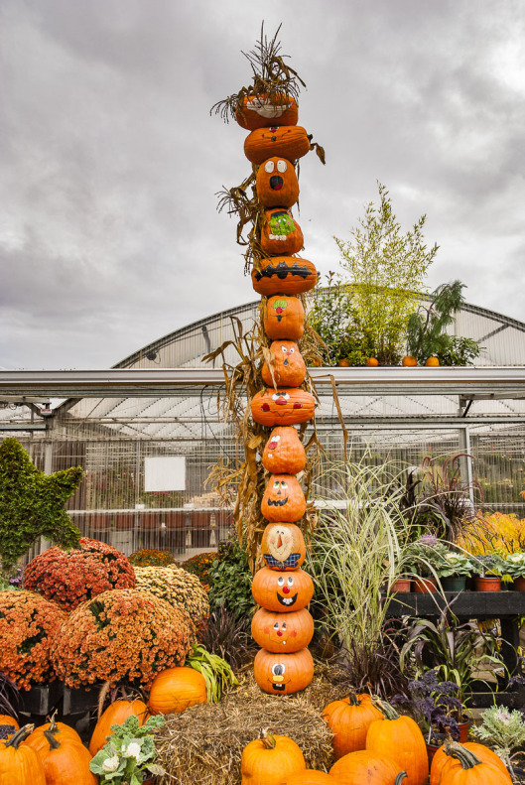
Example of a pumpkin totem pole. Note – we won’t be going quite this tall.
More details about the pumpkin totem poles and the event:
- We estimate businesses or groups will be able to decorate 7 – 10 pumpkins; however, we will let you know the exact dimensions of the poles no later than October 1st.
- Winthrop Arts will provide the poles, the signs for each business, and we will be in charge of erecting each totem pole.
- Pumpkins should be decorated in any way you would like (get creative!) – but please no carved pumpkins (they rot too quickly). Feel free to tailor them to your specific business!
- Please bring your staff, friends, and decorated pumpkins to the event on October 26th. You are welcome to hand out candy, coupons, or flyers with your company’s information.
- The timing for the event is as follows: Please arrive between 4 – 4:15pm to set up the pumpkins, Judging will begin at 5:15pm, Judging will be completed by 6pm and awards will be given out at 6/6:15pm.
- While the judges are making their decisions, we will have a water balloon toss!
- Costumes are encouraged for everyone (kids and adults)!
- The pumpkin totem poles along with the sponsor’s sign will stay up until November 1st. Additionally your company logo will be listed on our website through November.
- Pumpkins will not be returned after the event.
PARTICIPANT INFORMATION: WINTHROP ARTS’ TOTEM-LLY BEWITCHING PUMPKIN PARTY

Name of Business or Group _______________________________________________________
Contact Name ___________________________________________________________
Cell Phone _____________________________________
Email ___________________________________________________
Website (if applicable) _____________________________________________
Address of Business______________________________________________________________
City__________________________________________State_______________
Zip Code____________________

Participation in the Winthrop Arts’ Totem-lly Bewitching Pumpkin Party benefits Winthrop Arts, Inc., a nationally recognized 501(c)3 and your entire donation is tax-deductible. Winthrop Arts’ tax ID number is 45-1543450.
The sponsorship amount for this event is $250 and it is due by October 21, 2019. We accept cash, checks, or credit card payments made through our website.
_____cash _____check (Checks made out to “Winthrop Arts, Inc.”) _____CC (Accepted through our website)
Please submit fee and this application (mail or email) to:
Winthrop Arts Inc., 867 W. Bloomingdale Ave., Box 6301, Brandon, FL 33508 or info@winthroparts.org.
Questions can be directed to Kathy Collins at 813.758.5161.

PARTICIPANT: Signature Page

Please read carefully before signing and submitting.
Refund Policy
I understand that the fee for participating is considered a sponsorship and is non-refundable. I understand that by submitting this form and fee, I am agreeing to participate in the event being held on October 26, 2019. If for any reason, I can no longer participate, I will contact Winthrop Arts Management immediately.
SIGNED__________________________________________________________________
DATE _________________
Release Agreement
I, _________________________________________ agree to and hereby assume any and all risks of personal injuries, including death and risk of damages to my property, caused by or arising out of my involvement in the Winthrop Arts’ Totem-lly Bewitching Pumpkin Party.
If accepted, Winthrop Arts, Inc. has my permission to publish photos of the event, including photos of myself and our pumpkin designs, for the purpose of promoting, advertising and marketing the event and the organization.
SIGNED__________________________________________________________________
DATE _________________
Thank you so much for your support of Winthrop Arts!
www.winthroparts.org

